**Post Menopausal Osteoporosis**

**ABSTRACT:**

A significant portion of the Indian female population belongs to theperimenopausal and postmenopausal age groups. One of the complications associated with aging in women is weakening of bones and a decrease in bone mineral density (BMD). This has serious, debilitating consequences on a woman's life, leading to a reduced quality of life and an increased incidence of fractures. If the fracture involves the hip or vertebrae, it can be debilitating and have devastating consequences. Postmenopausal osteoporosis is associated with estrogen deficiency, which occurs when ovarian function declines with age. The role of estrogen in bone remodeling is very well understood after many years of research; Estrogen plays a role in both bone formation and preventing bone resorption. The diagnosis can be made using dual-energy x-ray absorptiometry (DEXA). The main goal of osteoporosis diagnostics is to elucidate the causes of the disease, elucidate the functions of biomarkers and their dynamic changes in response to therapy, and develop a new diagnostic strategy in combination with modern methods. Conventional treatments, including bisphosphonates, denosumab, estrogen replacement therapy, and teriparatide, have long been used in the treatment of osteoporosis. Some serious side effects led to discontinuation of therapy. However, the frequency of side effects is quite low. Developing new treatments for osteoporosis using mesenchymal stem cells or Chinese herbal therapies is of growing interest to researchers as they improve safety, effectiveness and cost- effectiveness. Improvements in both diagnostic and therapeutic strategies may facilitate personalized treatment of osteoporosis.

**Keywords:**

estrogen, bone remodelling process, dual energy x-ray absorptiometry,esenchymal stem cell, bisphosphonates, denosumab, estrogen replacement therapy

**INTRODUCTION AND BACKGROUND :**

**INTRODUCTION:**

Osteoporosis is a silent disease whose incidence has increased in recent years due to the increased life expectancy of patients .This condition affects the patient physically, mentally, economically and socially.[1]Over the past few years, significant advances have been made in understanding the mechanisms that control muscle and bone pathologies.

Additionally, the relationship between the immune system and bones has long been debated because bone loss is a problem of autoimmune and inflammatory diseases. In this context, T cells are thought to be responsible for osteoclast (OC) and osteoblast (OB) formation and the development of arthritis, bone metastasis, periodontitis, congenital adrenal hyperplasia (CAH), osteoporosis, and others. different diseases.[2-12]

**DEFINITION :**

In 1994, the World Health Organization published a definition based on the bone mineral density (BMD) T value and stated that bones with a T value bselow -2.5 were considered osteoporotic.[13]

**BACKGROUD**

The number of people living with osteoporosis is increasing and this number should continue to increase.80 percent of them must be women. The incidence of osteoporosis increases exponentially with age and increases significantly after menopause in women. The occurrence of osteoporosis is also associated with decreased bone density and increased incidence of fractures.[14]

**OSTEOPOROSIS:**

Osteoporosis is a chronic bone disease that weakens bones and causes bone loss in people with this disease, resulting from decreased bone mineral density (BMD). It is a serious illness with physical, social, psychological and financial consequences.[15,16]Osteoporosis is divided into primary osteoporosis and secondary osteoporosis. Primary osteoporosis is caused by the aging process of people. Secondary osteoporosis is caused by specific diseases.

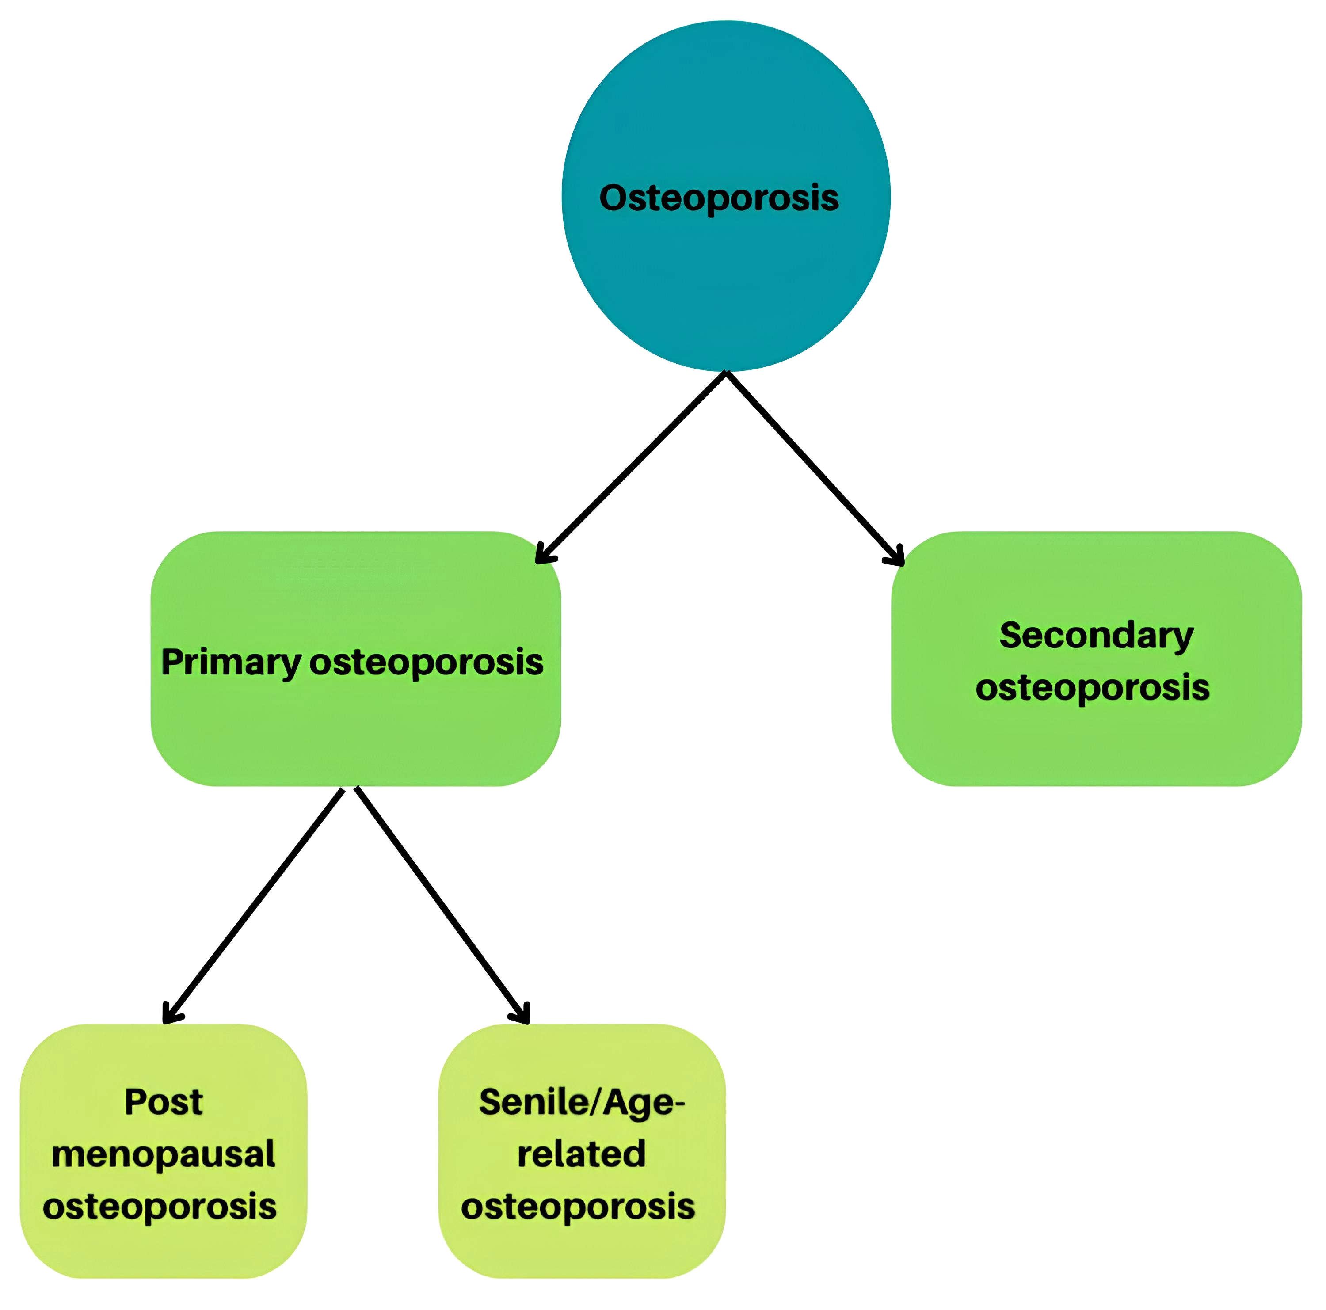

**Classification of osteoporosis**

Osteoporosis is of two types, primary and secondary. Postmenopausal osteoporosis is a type of primary osteoporosis

Although osteoporosis can affect people of all ages, women in the post-menopausal age group are particularly "at high risk" of osteoporosis. In fact, postmenopausal osteoporosis is the most common bone disease in developing countries .This can be better understood by understanding the role of estrogen in regulating bone formation in women.[18]

**BONE REMODELING :**

The bone healing process is strong and continuous throughout life; maintains bone size and quality, prevents overmineralized bones in the body, and controls bone socket by releasing stores that provide Ca2+ and phosphorus. It is important to understand that our bones do not stay the same throughout our lives. In fact, our bones (up to 10%) are renewed every year The bone turnover process is a tight link between bone resorption by osteoclasts and bone formation by osteoblasts .[19,20]

**The bone remodeling cycle includes five keys steps:**

Activation

This marks the beginning of the bone remodeling cycle, which occurs through the recruitment and activation of osteoclast precursor cells from the bloodstream. Activation can be: a) objective, for example, osteoclasts are selected for specific areas in old or damaged bones; these are the general discussion of orientation dendrites, together with the problems caused by osteocytes through their interactions; b) off-target, i.e. Osteoclast does not send to a specific location. . This allows calcium stores in the bones to be used by the body in response to changes in hormones such as PTH.

Resorption

Bone breakdown phase: Osteoclasts pump protons (H+), creating an acidic environment that degrades the bone surface. Matrix metalloproteinases and cathepsin K-like proteases then break down the collagen of the bone matrix. In healthy bones, this step of resorption is tightly controlled by controlling cell death of osteoclasts to ensure that no further resorption occurs.

Reversal

Here, a connection occurs between osteoclast resorption and osteoblast formation. Osteoblasts receive the signals and reach the outer surface of the bone, and the absorption is converted into bone formation by the action of cytokines such as IL-6.[32,33]

Formation

The process of forming new bone corresponds to two functions of osteoblasts: a) synthesis and release of osteoid matrix, rich in type 1 collagen; b) regulation of the osteoid mineralization process. The formation phase is where collagen is deposited and mineralized to form new bone.

Termination

This step indicates the apoptosis of osteoblasts when bone mineralization controlled by osteocytes is achieved through the release of osteogenic antagonists, or in other words, Wnt signaling pathway antagonists such as sclerostin. In apoptosis, osteoblasts can differentiate into bone cells or permanently differentiate into osteocytes.

**PATHOPHYSIOLOGY OF POSTMENOPAUSAL OSTEOPOROSIS:**

The crucial role of estrogen deficiency in the pathogenesis of osteoporosis is due to the fact that postmenopausal women are at greatest risk of developing the disease picture Bone metabolism in postmenopausal women is characterized by high bone turnover, defined as a simultaneous increase in bone resorption and bone formation. However, postmenopausal bone resorption exceeds bone formation, resulting in unbalanced bone turnover and rapid overall bone loss. In the first 5 years after menopause, bone loss occurs severely and predominantly in the trabecular bone, while in subsequent years the bone mass decreases more slowly and mainly affects the cortical and trabecular bone space, a process that can take more than 10 year.

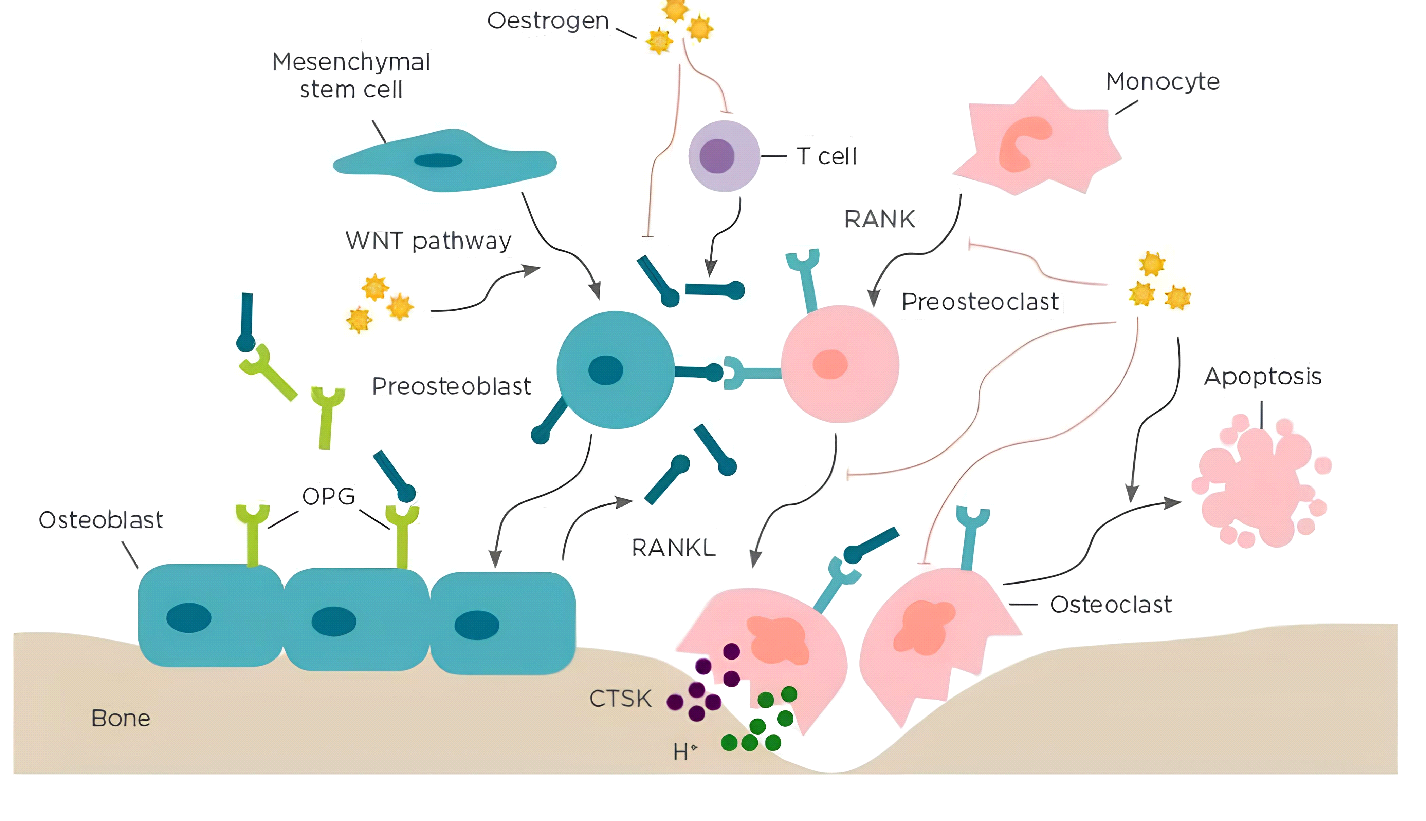Figure : Bone remodeling. Bone remodeling is based on the balance between osteoclastogenic bone resorption and osteoblastogenic bone formation, a crucial dynamic process during bone growth, development and regeneration. Osteoblasts originate from mesenchymal stem cells and specifically generate extracellular bone matrix via the WNT signaling pathway. Osteoclasts originate from the monocytic lineage and secrete bone resorption factors via the RANK/RANKL/OPG signaling pathway. In addition, estrogen also regulates bone remodeling by suppressing RANKL expression by T cells, mesenchymal stem cells and osteoblasts. CTSK: cathepsin K; OPG: osteoprotegerin; RANK: NFκB receptor activator; RANKL: receptor activator of NFκB ligand.

Therapeutic Strategies of Postmenopausal Osteoporosis

Osteoporosis treatment aims to reduce the incidence of vertebral and nonvertebral fractures that lead to disease-related morbidity and to stabilize or increase bone size and strength.

The two main treatments for osteoporosis are anti-catabolic and anabolic drugs, which reduce bone resorption and promote new bone formation, respectively.

Anticatabolic substances include bisphosphonates: etidronate, alendronate, rosedronate and zoledronic acid; estrogens and selective estrogen receptor modulators (SERMs); Roxifene; salmon calcitonin; and denosumab. The only anabolic drug currently available is teriparatide.

Bisphosphonate therapy reduces the risk of fractures, which is not seen with other available medications. Bisphosphonates are found at the mineral level of bones and reduce OC activity by inhibiting farnesyl pyrophosphate synthetase. It can be taken orally (daily, weekly, or monthly) or injected (quarterly or annually). Since it was first marketed in the United States in 1995, questions have been raised about its rare and seemingly unlikely side effects (osteonecrosis of the jaw, musculoskeletal pain, atrial fibrillation, atypical fractures, and esophageal cancer). No. From where. However, for most people with osteoporosis, the benefits of treatment outweigh the risks. Denosumab is a new first-line treatment in osteoporosis, a fully human monoclonal antibody directed against soluble RANKL.

Denosumab is the newest anti-bone resorbing agent with a novel mechanism of action. Its action is similar to OPG, preventing RANKL from binding to the OC receptor RANK; as a result, recruitment, growth and activity of OC are limited and bone resorption is reduced. Unlike bisphosphonates, denosumab does not accumulate in bones. Its half-life is approximately 26 days, and like other monoclonal antibodies, denosumab is cleared by reticuloendothelial cells and has no renal clearance.

**Treatment of osteoporosis**

Candidates requiring treatment for osteoporosis include :

1. Hip or spine fracture

2. T score <-2.5

3. T score between -1 to -2.5 with a probability of fracture as calculated by FRAX tool

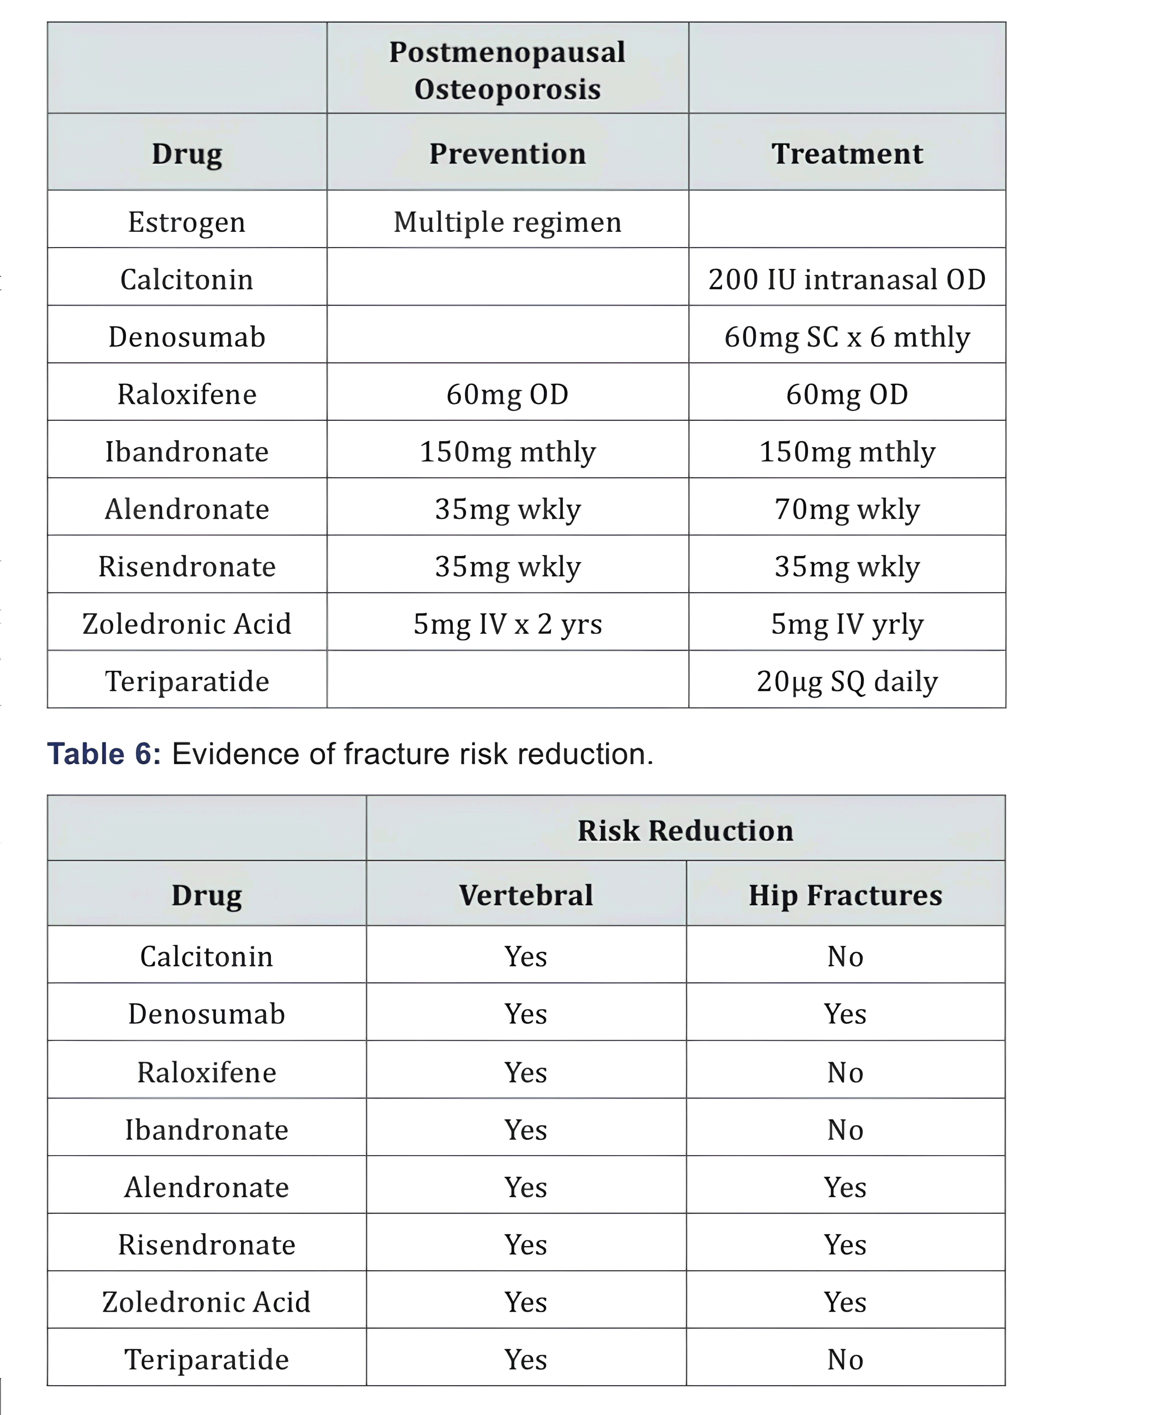

Recommended medications for postmenopausal osteoporosis are listed in Table 5, along with their dosages, and their potential effects on osteoporosis risk are noted in Table

6. Concomitant use of anti-osteoporotic medications is thought to reduce the risk of fractures better than using them alone. Medicine.

However, further research has led to this practice being discouraged. The use of discovered drugs, first the anabolic group, then the anti-absorption drugs[47-49]

**INDIVIDUALIZED LONG-TERM PHARMACOLOGICAL THERAPIES**

Experts have emphasized the concept of “targeted therapy”, in which specific targets are set to achieve long-term damage prevention (e.g. total hip T-score -2 and -1.5) [50] and treatment is individualized and based on aim. It is periodically re-evaluated [51]. Historically, BP is the first line of treatment for osteoporosis, and after years of use or lack of response, doctors may consider other treatments. By treatment method, doctors choose the drug or series of drugs that is most likely to achieve the goal over a given period of time, whether short (1 to 2 years for impending fracture risk) or long (1 to 2 years for fracture risk). risk of breakage). Higher pain should be 10 years). bones). It is important to note that achieving this goal does not mean that patients can stop treatment.

It is important to note that achieving this goal does not mean that patients can stop treatment. Article

Bouxsein and colleagues conducted a systematic review of clinical trials of all available pharmaceuticals and found that improvement in BMD was associated with reductions in hip and lower pelvis. This suggests that BMD may serve as a target and endpoint for fracture risk.

Endocrine Society guidelines recommend that postpartum women who are at high risk for osteoporosis should continue BP treatment uninterrupted if they remain at high risk after 3 to 5 years of treatment, but also note that there is little evidence to support long-term treatment recommendations. A review of data in patients discharged from BP found that the risk of new bone healing was 20% to 40% higher compared to receiving BP, and the risk of osteoporosis was almost doubled. This suggests that the "holiday drug" may put the patient at risk. Not all patients use BP safely. We should treat osteoporosis like chronic diseases such as hypertension and diabetes, which we believe will improve in the long term, although there is no long-term evidence.

**Risedronate**

In the Vertebral Efficacy of Risedronate Extended Multinational (VERT-MN) Vertebral Efficacy study, patients received risedronate (n=31) for 7 years or placebo for 5 years. They received rosedronate treatment for 2 years (n=30). Treatment was discontinued at year 8 in both groups. Bone turnover markers (BTM) increased at baseline and hip and trochanteric BMD decreased in both the 2- and 7-year risedronate groups; However, the risk of new bone fractures was not increased [56]. Given the small number of patients in each group, it is difficult to draw any conclusion from these results other than the absence of residual BMD 1 year after drug discontinuation.

**Alendronate**

Fracture Intervention Study (FLEX; an extension of the FIT study), postmenopausal women who received alendronate daily for an average of 5 years discontinued treatment (n = 428) or continued alendronate. Treatment was either stopped for 5 years (n=428) or alendronate was continued for another 5 years (n=643). Hip BMD growth is stable after 3 years of alendronate treatment. Untreated women showed increased BMD and increased BTM; reached baseline BMD levels 5 years after stopping treatment [57]. The risk of vertebral fracture treatment was reduced in the group that continued alendronate (5.3% versus 2.4%; relative risk, 0.45; 95% confidence interval, 0.24 to 0.85). However, continued use of alendronate did not provide additional protection against bone loss.

**CONCLUSION:**

Over the past few years, many studies have been conducted to understand how the immune system affects and controls bones in the body and pathological diseases through the immune system. Although most of the information comes from animal studies, new evidence has recently accumulated regarding the interaction between the immune system and bone in many human diseases, such as postmenopausal osteoporosis.

These data suggest that bone loss due to menopausal estrogen deficiency is an effect of multiple pathways and cytokines that coordinately regulate osteoclastogenesis and osteoblastogenesis. Among these cytokines, RANKL and TNFα appear to play an important role in OC formation and function, while IL-17 promotes bone formation by promoting OC production and inhibiting OB differentiation.

These findings have the potential to lead to the development of new therapeutic strategies for the treatment of bone diseases. In this context, denosumab, a fully human monoclonal antibody against soluble RANKL, represents a new advance in bone healing with a novel mechanism of action that reduces bone resorption and resorption.

Antiresorptive drugs such as amino-BPs and more recently DMAbs have been at the forefront of osteoporosis treatment over the past three decades. Because osteoporosis is a chronic disease, bone healing can continue throughout the patient's life. We discuss how best to use available drug options for postmenopausal osteoporosis to provide lasting bone protection in patients at high risk of osteoporosis. The benefits of treating osteoporosis far outweigh the low risks.

**REFERENCES:**

1. Centers for Disease Control and Prevention [CDC][2006] Fatalities and injuries from falls among older adults-United States, 1993-2003 and 2001-2005 MMWR Morb Mortal Weekly REP 55[45]:1221-1224

2. A. Clowes, B. L. Riggs, and S. Khosla, "The role of the immune system in the pathophysiology of osteoporosis,"Immunological Reviews, vol. 208, pp. 207-227,2005.

3. L. Ginaldi, M. C. Di Benedetto, and M. De Martinis, "Osteoporosis, inflammation and ageing," Immunity and Ageing, vol. 2, article 14, 2005.

4. J. R. Arron and Y. Choi, "Bone versus immune system," Nature, vol. 408, no. 6812, pp. 535-536, 2000.

5. S. Kotake, N. Udagawa, M. Hakoda et al., "Activated human T cells directly induce osteoclastogenesis from human monocytes:

possible role of T cells in bone destruction in reumatoid arthritis patients," Arthritis & Rheumatism, vol. 44, pp. 1003-1012, 2001.

6. I. Roato, M. Grano, G. Brunetti et al.,

"Mechanisms of spontaneous osteoclastogenesis in cancer with bone involvement," FASEB Journal, vol. 19, no. 2, pp. 228-230, 2005.

7. I. Roato, G. Brunetti, E. Gorassini et al., "IL-7 up-regulates TNF-a-dependent

osteoclastogenesis in patients affected by solid tumor," PLoS ONE, vol. 1, no. 1, article e124, 2006.

8. G. Brunetti, S. Colucci, P. Pignataro et al., "T cells support osteoclastogenesis in an in vitro model derived from human periodontitis patients," Journal of Periodontology, vol. 76, no. 10, pp. 1675-1680, 2005.

9. S. Colucci, G. Brunetti, F. P. Cantatore et al.,

"Lymphocytes and synovial fluid fibroblasts support osteoclastogenesis through RANKL, TNFa, and IL-7 in an in vitro model derived from human psoriatic arthritis," Journal of Pathology, vol. 212, no. 1, pp. 47-55, 2007

10.M. F. Faienza, G. Brunetti, S. Colucci et al. "Osteoclastogenesis in children with 21-

hydroxylase deficiency on long-term glucocorticoid therapy: the role of receptor activator of

nuclear factor-B ligand/osteoprotegerin imbalance," Journal of Clinical Endocrinology and Metabolism, vol. 94, no. 7, pp. 2269-2276, 2009.

11. G. Brunetti, M. F. Faienza, L. Picente et al.,

"High dickkopf-1 levels in sera and leukocytes from children with 21-hydroxylase deficiency on chronic glucocorticoid treatment," American

Journal of Physiology, vol. 304, pp. 546-554,2013.

12. A. Ventura, G. Brunetti, S. Colucci et al.,

"Glucocorticoid-induced osteoporosis in children with 21-hydroxylase deficiency,"

BioMed Research International, vol. 2013,

Article ID 250462, 8 pages, 2013.

View at: Publisher Site | Google Scholar

[13.is JA, Melton LJ III, Christiansen C, Johnston CC, Khaltaev N (1994)

The diagnosis of osteoporosis. J Bone Miner Res 9(8): 1137-1141.

14.urge R, Dawson Hughes B, Solomon DH, Wong JB, King A, et al. (2007)

Incidence and economic burden of osteoporosis-related fractures in the United States, 2005-2025. J Bone Miner Res 22(3): 465-475.

15.The epidemiology and management of postmenopausal osteoporosis: a viewpoint from Brazil. Baccaro LF, Conde DM, Costa-Paiva L, Pinto-Neto AM. Clin Interv Aging. 2015;10:583–591.

16.Osteoporosis prevention, diagnosis, and therapy. NIH Consensus Development Panel. JAMA. 2001;285:785–795.

17.Secondary causes of osteoporosis. Fitzpatrick LA. Mayo Clin Proc. 2002;77:453–468.

18.Estrogen promotes apoptosis of murine osteoclasts mediated by TGF-beta. Hughes DE, Dai A, Tiffee JC, Li HH, Mundy GR, Boyce BF. Nat Med. 1996;2:1132–1136.

19.The bone remodelling cycle. Kenkre JS, Bassett J. Ann Clin Biochem. 2018;55:308–327.

20.Re-thinking the bone remodeling cycle mechanism and the origin of bone loss. Delaisse JM, Andersen TL, Kristensen HB, Jensen PR, Andreasen CM, Søe K. Bone. 2020;141:115628.

21.The bone remodelling cycle. Kenkre JS, Bassett J. Ann Clin Biochem. 2018;55:308–327.

22. Prevention and treatment of postmenopausal osteoporosis. Tella SH, Gallagher JC. J Steroid Biochem Mol Biol. 2014;142:155–170.

23.Targeted and nontargeted bone remodeling: relationship to basic multicellular unit origination and progression. Parfitt AM. Bone. 2002;30:5–7.

24. Targeted and nontargeted remodeling. Burr DB. Bone. 2002;30:2–4. [PubMed] [Google Scholar]

25. The osteocyte: key player in regulating bone turnover. Goldring SR. RMD Open. 2015;1:0.

26. Osteocyte regulation of bone mineral: a little give and take. Atkins GJ, Findlay DM. Osteoporos Int. 2012;23:2067–2079.

27. Increased intracortical remodeling following fatigue damage. Mori S, Burr DB. Bone.

28. Osteopetrosis. Tolar J, Teitelbaum SL, Orchard PJ. N Engl J Med. 2004;351:2839–2849.

29. Microelectrode studies on the acid microenvironment beneath adherent macrophages and osteoclasts. Silver IA, Murrills RJ, Etherington DJ. Exp Cell Res. 1988;175:266–276.

30. Matrix metalloproteinases (MMP) and cathepsin K contribute differently to osteoclastic activities. Delaissé JM, Andersen TL, Engsig MT, Henriksen K, Troen T, Blavier L. Microsc Res Tech. 2003;61:504–513.

31. Regulation of apoptosis in osteoclasts and osteoblastic cells. Xing L, Boyce BF. Biochem Biophys Res Commun. 2005;328:709–720.

32. Coupling the activities of bone formation and resorption: a multitude of signals within the basic multicellular unit. Sims NA, Martin TJ. Bonekey Rep. 2014;3:481. [PMC free article]

33.Deposition of cement at reversal lines in rat femoral bone. Zhou H, Chernecky R, Davies JE. J Bone Miner Res. 1994;9:367–374.

34. The amazing osteocyte. Bonewald LF. J Bone Miner Res. 2011;26:229–238. [PMC free article]

35.International Osteoporosis Foundation. Bone Turnover Markers Educational Course

36.Manolagas SC et al. The role of estrogen and androgen receptors in bone health and disease. Nat Rev Endocrinol. 2013;9(12):699-712.

37.. M. Brandão, G. P. Machado, and A. Acurcio Fde, “Pharmacoeconomic analysis of strategies to treat postmenopausal osteoporosis: a systematic review,” Revista Brasileira de Reumatologia, vol. 52, pp. 924–937, 2012.

38.C. MacLean, S. Newberry, M. Maglione et al., “Systematic review: comparative effectiveness of treatments to prevent fractures in men and women with low bone density or osteoporosis,” Annals of Internal Medicine, vol. 148, no. 3, pp. 197–213, 2008.

39. A. Papaioannou, S. Morin, A. M. Cheung et al., “2010 clinical practice guidelines for the diagnosis and management of osteoporosis in Canada: summary,” Canadian Medical Association Journal, vol. 182, no. 17, pp. 1864–1873, 2010.

40. C. J. Rosen and J. P. Bilezikian, “Clinical review 123: hot topic—anabolic therapy for osteoporosis,” Journal of Clinical Endocrinology and Metabolism, vol. 86, no. 3, pp. 957–964, 2001.

41. J. M. Belavic, “Denosumab, (Prolia): a new option in the treatment of osteoporosis,” Nurse Practitioner, vol. 36, pp. 11–12, 2011.

42. M. J. Favus, “Bisphosphonates for osteoporosis,” The New England Journal of Medicine, vol. 363, no. 21, pp. 2027–2035, 2010.

43. N. B. Watts and D. L. Diab, “Long-term use of bisphosphonates in osteoporosis,” Journal of Clinical Endocrinology and Metabolism, vol. 95, no. 4, pp. 1555–1565, 2010.

44. P. D. Miller, “A review of the efficacy and safety of denosumab in postmenopausal women with osteoporosis,” Therapeutic Advances in Musculoskeletal Disease, vol. 3, pp. 271–282, 2011.

45.M. D. Moen and S. J. Keam, “Denosumab: a review of its use in the treatment of postmenopausal osteoporosis,” Drugs and Aging, vol. 28, no. 1, pp. 63–82, 2011.

46.R. Baron, S. Ferrari, and R. G. G. Russell, “Denosumab and bisphosphonates: different mechanisms of action and effects,” Bone, vol. 48, no. 4, pp. 677–692, 2011.

47. Compston JE, Watts NB (2002) Combination therapy for postmenopausal osteoporosis. Clin Endocrinol (Oxf) 56(5): 565-569.

48.Black DM, Greenspan SL, Ensrud KE, Palermo L, McGowan JA, et al.

(2003) The effects of parathyroid hormone and alendronate alone or in combination in postmenopausalosteoporosis. N Engl J Med 349(13): 1207-1215.

49. Watts NB, Harris ST, Genant HK, Wasnich RD, Miller PD, et al. (1990) Intermittent cyclical etidronate treatment of postmenopausal

50. Ferrari S, Libanati C, Lin CJF, Brown JP, Cosman F, Czerwinski E, et al. Relationship between bone mineral density t-score and nonvertebral fracture risk over 10 years of denosumab treatment. J Bone Miner Res 2019;34:1033–40. ArticlePubMed

51. Cummings SR, Cosman F, Lewiecki EM, Schousboe JT, Bauer DC, Black DM, et al. Goal-directed treatment for osteoporosis: a progress report from the ASBMR-NOF working group on goal-directed treatment for osteoporosis. J Bone Miner Res 2017;32:3–10. ArticlePubMed

52. Lewiecki EM. Osteoporosis: treat-to-target. Curr Osteoporos Rep 2017;15:103–9. ArticlePubMed

53.Bouxsein ML, Eastell R, Lui LY, Wu LA, de Papp AE, Grauer A, et al. Change in bone density and reduction in fracture risk: a meta-regression of published trials. J Bone Miner Res 2019;34:632–42. ArticlePubMed

54. Shoback D, Rosen CJ, Black DM, Cheung AM, Murad MH, Eastell R. Pharmacological management of osteoporosis in postmenopausal women: an Endocrine Society guideline update. J Clin Endocrinol Metab 2020;105:dgaa048.

ArticlePubMed55. Dennison EM, Cooper C, Kanis JA, Bruyere O, Silverman S, McCloskey E, et al. Fracture risk following intermission of osteoporosis therapy. Osteoporos Int 2019;30:1733–43. ArticlePubMed

55. Dennison EM, Cooper C, Kanis JA, Bruyere O, Silverman S, McCloskey E, et al. Fracture risk following intermission of osteoporosis therapy. Osteoporos Int 2019;30:1733–43. ArticlePubMed

56. Eastell R, Hannon RA, Wenderoth D, Rodriguez-Moreno J, Sawicki A. Effect of stopping risedronate after long-term treatment on bone turnover. J Clin Endocrinol Metab 2011;96:3367–73. ArticlePubMedPMC

57. Black DM, Schwartz AV, Ensrud KE, Cauley JA, Levis S, Quandt SA, et al. Effects of continuing or stopping alendronate after 5 years of treatment: the Fracture Intervention Trial Long-term Extension (FLEX): a randomized trial. JAMA 2006;296:2927–38.ArticlePubMed